Dated 2013

Inter Authority Agreement
Between

Harrow Council

And

Brent Council

And

Ealing Council

Contents

Clause
1. Background 3
2. Key objectives 3
3. Principles of collaboration 4
4. Project governance 4
5. Roles and responsibilities 6
6. Escalation 7
7. Intellectual property 7
8. Term and termination 8
9. Variation 8
10. Charges and liabilities 8
11. Status 9
12. Governing law and jurisdiction 9

Annex
Annex A. Key Objectives
Annex B. Governance Structures 12
Annex C. Contributions 13
annex d. SLAs………………………………………………………
11
THIS AGREEMENT is dated 2013
Parties
The Parties to this Inter Authority Agreement (IAA) are:
- The Mayor and Burgesses of the London Borough of Harrow of Civic Centre, Station Road, Harrow HA1 2UH (Harrow).
- The Mayor and Burgesses of the London Borough of Brent of Town Hall, Forty Lane, Wembley, HA9 9HD (Brent)
- The Mayor and Burgesses of the London Borough of Ealing of Perceval House, 14-16 Uxbridge Road, Ealing, London, W5 2HL (Ealing) (together the “Parties”)
- Background
  - Harrow Brent and Ealing are working together to procure leisure and library services (the ‘Initial Project Phase’) and have signed a Joint Working Memorandum of Understanding which records the basis on which they have collaborated with each other on the Initial Project Phase.
  - The Initial Project Phase has reached contract award stage and the Parties now wish to record the basis on which they will deal with post contract award matters (the ‘Post Contract Award Project Phase’)
  - This IAA sets out:
    - the key objectives of the Parties for the Post Contract Award Project Phase;
    - the principles of good faith and collaboration;
    - the Post Contract Award Project Phase governance structures the Parties will put in place;
    - the respective roles and responsibilities the Parties will have, and
    - the Parties rights and responsibilities if one or more of the Parties wishes to end some or all of the Post Contract Award Project Phase arrangements set out in this IAA
- Key objectives for the Post contract award project phase
  - The Parties shall undertake the Post Contract Award Project Phase to achieve the key objectives set out in Annex A to this IAA (Key Objectives).
- Principles of collaboration
The Parties agree to adopt the following principles when carrying out the Post Contract Award Project Phase (Principles):
    - collaborate and co-operate. Establish and adhere to the governance structure set out in this IAA to ensure that activities are delivered and actions taken as required;
    - be accountable. Take on, manage and account to each other for performance of the respective roles and responsibilities set out in this IAA;
    - be open. Communicate openly about major concerns, issues or opportunities relating to the Post Contract Award Project Phase;
    - learn, develop and seek to achieve full potential. Share information, experience, materials and skills to learn from each other and develop effective working practices, work collaboratively to identify solutions, eliminate duplication of effort, mitigate risk and reduce cost;
    - adopt a positive outlook. Behave in a positive, proactive manner;
    - adhere to statutory requirements and best practice. Comply with applicable laws and standards including EU procurement rules, data protection and freedom of information legislation;
    - act in a timely manner. Recognise the time-critical nature of actions and respond accordingly to requests for support;
    - manage stakeholders effectively;
    - deploy appropriate resources. Ensure sufficient and appropriately qualified resources are available and authorised to fulfil the responsibilities set out in this IAA. [In particular the Parties agree to make the contributions detailed in Annex C to this IAA]; and
    - act in good faith to support achievement of the Key Objectives and compliance with these Principles.
- Post Contract Award Project Phase governance
  - Overview
The governance structure defined below provides a structure for the development and delivery of the Post Contract Award Project Phase.
  - Guiding principles
The following guiding principles are agreed. The Post Contract Award Project Phase's governance will:
    - provide strategic oversight and direction;
    - be based on clearly defined roles and responsibilities at organisation, group and, where necessary, individual level;
    - align decision-making authority with the criticality of the decisions required;
    - be aligned with the Post Contract Award Project Phase scope (and may therefore require changes over time);
    - leverage existing organisational, group and user interfaces;
    - provide coherent, timely and efficient decision-making; and
    - correspond with the key features of the Post Contract Award Project Phase governance arrangements set out in this IAA.
  - Contract Operational Management

(a) Ealing will lead on Leisure Contract Management across all three Authorities
(b) Each Authority will retain responsibility for its own sports development teams, subject to on-going review

(c) Harrow will lead on Libraries Contract Management for Ealing and Harrow

  - Service Level Agreements

Service Level Agreements (SLAs) (set out in Annex D) between the Parties will underpin the Lead Authority’s management of the Contractor for both the Leisure and Library Contracts
  - Reporting

Project reporting shall be undertaken at Head of Service level and in accordance with the SLAs

At Member and Senior Officer level, policy and strategic matters will remain with each Authority. The level of Member engagement with the responsible officer and Contractors will remain unchanged
- Roles and responsibilities
  - The Parties shall undertake the following roles and responsibilities to deliver the Post Contract Award Project Phase:

Activity | Harrow | Brent | Ealing
Leisure Contract Management | Assure | Assure | Lead
Libraries Contract Management | Lead | N/A | Assure
Sports Development | Lead | Lead | Lead
Policy and Strategic Matters | Lead | Lead | Lead
Any Others?
  - For the purpose of the table above:
Lead: the party that has principal responsibility for undertaking the particular task, and that will be authorised to determine how to undertake the task. The Lead must act in compliance with the Objectives and Principles at all times, and consult with the other party in advance if they are identified as having a role to Assure the relevant activity;
Assure: the party that will defer to the Lead on a particular task, but will have the opportunity to review and provide input to the Lead before they take a final decision on any activity. All assurance must be provided in a timely manner. Any derogations raised must be limited to raising issues that relate to specific needs that have not been adequately addressed by the Lead and/or concerns regarding compliance with the Key Objectives and Principles.
  - Prior to Contract commencement the party with the lead role for any aspect of the Post Contract Award Project Phase shall develop a delivery plan for that part of the Post Contract Award Project Phase which shall identify the following:
    - the key milestones for the delivery of the Key Objectives;
    - what employees (other than employees identified in this IAA) will be required to work on the Post Contract Award Project Phase;
    - whether any staff will need to be seconded from one party to the other;
    - what staff will require access to the premises of the other party;
    - [INSERT OTHERS].
Each delivery plan must be approved by Heads of Service prior to being implemented.
- Escalation
  - If any party has any issues, concerns or complaints about the Post Contract Award Project Phase, or any matter in this IAA, that party shall notify the other party or parties and the Parties shall then seek to resolve the issue by a process of consultation. If the issue cannot be resolved within a reasonable period of time, the matter shall be escalated to the relevant directors of the Parties, who shall decide on the appropriate course of action to take. If the matter cannot be resolved by the directors within 14 days, the matter may be escalated to the chief executives of the Parties for resolution.
  - If any party receives any formal inquiry, complaint, claim or threat of action from a third party (including, but not limited to, claims made by a Contractor or requests for information made under the Freedom of Information Act 2000 or the Environmental Information Regulations 2004) in relation to the Post Contract Award Project Phase, the matter shall be promptly referred to the Heads of Service (or their nominated representatives). No action shall be taken in response to any such inquiry, complaint, claim or action, to the extent that such response would adversely affect the Post Contract Award Project Phase, without the prior approval of the Heads of Service (or their nominated representatives).
- Intellectual property
  - The Parties intend that notwithstanding any secondment or any agreement to the contrary any intellectual property rights created in the course of the Post Contract Award Project Phase shall vest in the party whose employee created them, or in the case of any intellectual property rights created jointly by employees of the Parties jointly in the Parties.
  - Where any intellectual property right vests in any party in accordance with the intention set out in clause 7.1 above, that party shall grant an irrevocable licence to the other parties to use that intellectual property for the purposes of the Post Contract Award Project Phase.
- Term and termination
  - This IAA shall commence on the date of signature by the Parties, and shall expire on the date that the last Contract ends, subject to a duty on the Parties to co-operate and work together in relation to post Contract matters, including but not limited to the duty to transfer information and assets and the like as appropriate or in accordance with any express agreement between the Parties.
  - The Parties recognise that one or more of them might decide to exit partly or wholly either or both of the Leisure or Libraries Contracts before the Contract expiry date and that this could have financial and/or Contract management and operational implications for the remaining party or parties. Therefore the Parties agree that in these circumstances they will consult in a timely and constructive manner with the other party or parties and make all reasonable efforts to minimise financial and/or Contract management and operational consequences for the remaining parties, including but not limited to the timely transfer of information and assets as appropriate. However the Parties acknowledge and agree that the exiting party shall have no liability to the remaining parties for any alleged losses, increase in costs or any other claims whatsoever.
- Variation
This IAA, including the Annexes, may only be varied by written agreement of the Parties
- Charges and liabilities
  - Except as otherwise provided, the Parties shall each bear their own costs and expenses incurred in complying with their obligations under this IAA.
  - The Parties agree to share the costs and expenses arising in respect of the Post Contract Award Project Phase between them [in accordance with the Contributions Schedule set out in Annex C to this IAA]
  - The Parties shall remain liable for any losses or liabilities incurred due to their own or their employee's actions and no party intends that any other party shall be liable for any loss it suffers as a result of this IAA.
- Status
  - This IAA is not intended to be legally binding, and no legal obligations or legal rights shall arise between the Parties from this IAA. The Parties enter into the IAA intending to honour all their obligations.
  - Nothing in this IAA is intended to, or shall be deemed to, establish any partnership or joint venture between the Parties, constitute either party as the agent of the other party, nor authorise either of the Parties to make or enter into any commitments for or on behalf of the other party.
- Governing law and jurisdiction
This IAA shall be governed by and construed in accordance with English law and, without affecting the escalation procedure set out in clause 6, each party agrees to submit to the exclusive jurisdiction of the courts of England and Wales.

Signed for and on behalf of Harrow
Signature: | ............................................
Name: | ............................................
Position: | ............................................
Date: | ............................................
Signed for and on behalf of Brent
Signature: | ............................................
Name: | ............................................
Position: | ............................................
Date: | ............................................
Signed for and on behalf of Ealing
Signature:
Name:
Position:
Date:
CONTACT POINTS
Harrow
Name: | ............................................
Office address: | ............................................
 | ............................................
Tel No: | ............................................
E-mail Address: | ............................................
Brent
Name: | ............................................
Office Address: | ............................................
 | ............................................
Tel No: | ............................................
E-mail Address: | ............................................
Ealing
Name:
Office Address:
Tel No:
E-mail Address:
- Key Objectives

The Key Objectives

- To manage the day to day running of Ealing, Brent and Harrow’s Leisure Services and Ealing and Harrow’s Libraries

- To deliver the maximum cash benefit from a move to single contracts for Leisure provision across the three boroughs; and Libraries Provision across Harrow and Ealing

- To provide effective shared contract management of the Leisure and Libraries Contracts as detailed in the Service Level Agreements

- [INSERT OTHER DETAILS]

- Governance Arrangements
- Remit:
- actions requiring approval.
- Decision-making:
- named individuals.
- voting rights.
- Meetings:
- frequency.
- quorum.
- premises.
- notice.

- Contributions
[INSERT DETAILS OF CONTRIBUTIONS (INCLUDING FINANCIAL, STAFFING, PREMISES, USE OF IT ETC) THAT THE PARTIES ARE WILLING TO COMMIT. THIS SHOULD ALSO INCLUDE ANY ARRANGEMENTS FOR CROSS-CHARGING AND OTHER PROJECT COSTS (FOR EXAMPLE ANY CONSULTANT'S COSTS THAT MAY NEED TO BE PAID)]

ANNEX D. Service Level Agreements

Ealing, Harrow Libraries

Shared Service
Contract Governance and SLA Agreement

Table of contents
1 Introduction …………………………………………………………16
1.1 Introduction 16
1.2 Purpose 16
1.3 Scope 16
The Agreement 17
1.4 Agreement Overview 17
1.5 Periodic review of SLA 17
1.6 Individual Borough Sovereignty 17
1.7 Responsibilities of Head of Service / Assistant Director (Lead Officer) 17
2 Service AGREEMENTS 19
2.1 Service Agreement - Libraries 19
2.2 Resourcing 22
2.3 Payment Schedule 22
Appendix A – Facilities in SCope of the SLA 23
Appendix C – Structure Charts 24

Introduction

Introduction
In order to deliver the maximum cash benefit from a move to single contracts for Leisure provision across the three boroughs; and Libraries Provision across Harrow and Ealing; the options for Sharing common functions have been considered throughout the development of the joint procurement.
An options paper in March 2012 identified a recommended option for operational management of the Joint Contracts, with current Heads of Service remaining in place, with each borough managing a functional specialism(s) for other boroughs. Steering committee agreed that this recommended approach should be developed further to a formal proposal on the structure to support the shared model.
Following further development, the following allocation of accountabilities was proposed:
- Ealing to lead on Leisure Contract Management, across three boroughs
- Each borough will retain responsibility for their own sports development teams.
- Harrow to lead on Libraries Contract Management for Ealing and Harrow (Subject to on-going review)
This proposal was presented to Steering Committee in July 2012, they agreed that this structure will be recommended to Cabinets and Executives in February and March 2013, alongside the recommended decision on successful suppliers for the Leisure and Libraries Contracts.
This paper documents the Service Level Agreement (SLA), between the boroughs that will underpin the Lead Borough management of the Libraries Contractor.

Purpose
The purpose of this document is to ensure that all required elements are in place to provide effective shared contract management of the Libraries Contractor.
The goal is that the Senior Officer in the three boroughs agree the documented SLAs as the agreed service provision between the boroughs.
The objectives of the SLA are to:
- Provide a clear and unambiguous statement of what the Customer Boroughs can expect from the Service Providing Borough
- Present measures of the Services that will be provided to ensure that performance to the SLA can be tested
- Ensure that there is a match between the expected services and the planned service delivery

Scope
The scope of the SLA includes the management of the contract(s) to provide Libraries services. A full list of in scope facilities is listed in Appendix A.
The scope of this options review excludes the following:
- Harrow Music Services
- Harrow Heritage
- Harrow Arts Centre
- Ealing Adults Learning
- Pitzhanger House and Gallery
- Ealing Arts and Heritage

The Agreement

Agreement Overview
This agreement represents a Service Level Agreement (SLA), between the following Parties:
- London Borough of Harrow (Service Provider) and London Borough of Ealing (Customer) for provision of Contract Management for Libraries Services
The role of the Service Provider Borough is detailed in the Service Level section, below.

Periodic review of SLA
The SLA will be reviewed annually, as part of the annual contract review processes. The service level described, anticipates a higher level of interaction with the contractor in the first year of operation of the contract.

Individual Borough Sovereignty
At Member and Senior Officer level, policy and strategic matters will remain with each borough. The level of Member engagement with the responsible officer and contractors will remain unchanged, this is captured in the Service Agreements, below.

Responsibilities of Head of Service / Assistant Director (Lead Officer)
The responsible officers in both boroughs will retain ownership of the strategic direction of the Boroughs Library Services.
In both boroughs, The Heads of Service / Assistant Directors have responsibilities that are broader than the scope of the Libraries contract. The Heads of Service / Assistant Directors will retain the responsibility as Lead Officer for Libraries for their borough; owning the subject matter strategy for their service.
The Customer Borough will ensure that all staff and facilities are handed over to the Contractor on first day of contract; and will resolve any Staff Transfer issues identified after go-live.
The SLA is owned in the Customer Borough at Head of Service Level, any additional dissemination of information to Directors, Board and Cabinet / Executive; will continue to be undertaken in a similar manner to current processes and procedures.

Ealing Responsibilities with Respect to Inter-serve
While Ealing’s contractual relationship with Inter-serve is in place. Ealing will provide access to the Inter-serve Client Management resource to the Service Provider Borough.

Development of Strategic Partnering
The aim of the Libraries Contract is wider than simple business as usual running of Libraries. Throughout the period of the contract the Heads of Service / Assistant Directors, will expect the Libraries Contractor to adapt to the boroughs’ evolving requirements and strategy for Libraries.
Work to evolve the contractual relationship, to ensure on-going innovation in the delivery of library service will be the responsibility of the Service Provider, acting on behalf of the Customer Borough.

Contract Mobilisation
It is anticipated that during the first few months of the new contractual arrangements being in place, there will be additional resources needed to manage exceptions and incidents. This additional resourcing is outside of the scope of this SLA and the additional resources will be provided by the impacted borough. Arrangements for the Contract Mobilisation are covered in the implementation plan.

Service AGREEMENTS

Service Agreement - Libraries
The following Table Details the services that will be provided by the London Borough of Harrow for the Libraries Contract.

Service Area | Service Level Description | KPI
Meetings with Supplier | Monthly Business review (MBR) Meetings, including Lead Officer from Customer Borough and borough partner (Ealing)  Review of performance to include, but not be limited to utilities usage data and efforts to control utilities use, staff training, and expenditure on stock and performance targets agreed within the service contract  Review of change control proposals and actions  Annual Contract Meeting will be held involving Portfolio Holders and Lead Officers | All MBRs / Annual reviews conducted  Papers will be circulated at least 5 working days in advance and draft minutes published within 5 working days.
Review of Supplier Metrics and management information | Analyse supplier metrics and provide commentary and report to Head of Service of Customer Borough on a monthly basis | Analysis provided to Head of Service at least 5 working days prior to the MBR meeting
Management of Mobilisation process, staffing and facilities | Outstanding and on-going mobilisation issues and actions The Service Provider will manage the completion of these activities; however, the boroughs will provide additional resources for mobilisation (pre and post contract start date) | N/A
Site Visits | Undertake site visits monthly, and review sites, against checklist (TBC) | Record of 12 visits per facility
Maintenance Assurance | Ensure maintenance issues are handled in a timely manner and do not affect opening the service to customers; and minimisation of impact on service quality during times where unavoidable rectification has to happen during opening hours. to the public. In particular, if either borough retains any maintenance functions, to ensure smooth relationships between maintenance provider and service provider | TBC
Review of Supplier Metrics and management information | Analyse supplier metrics and provide commentary and report to Head of Service of Customer Borough on a monthly basis | Analysis provided to Head of Service at least 5 working days prior to the MBR meeting
Reporting to Head of Service | Monthly report on performance to Senior Management in digest format with summarised headlines for individual borough service. This will need to highlight trends and see if they are localised or replicated across both areas. This will be in a standardised format reporting on visits, issues, IT usage, events, partnership contact, failure to open/provide service and reasons for occurrences IT outages, maintenance issues, customer complaints, number of member complaints dealt with | Report provided to Head of Service at least 5 working days prior to the MBR meeting
Preparation of Reports for members | From time to time during the contract,  Actual report preparation in plain English and presentation to be undertaken by Customer Head of Service | Initially report bi-annually to members (moving to annually after Year 1).
Scrutiny reports | Prepare Scrutiny reports for Customer Head of Service  Attend, and respond as required, Scrutiny meetings at Customer site | 1st Draft Scrutiny report provided 10 working days before 1st Submission date.
Rectification | In the event of consistent under-performance by the contractor, to develop a performance improvement plan and manage the Contractor through to completion of the improvement plan.  Trouble shoot, co-ordinate and resolve blockages and obstacles to contract delivery on client side to ensure delivery of contract | N/A
Assurance | Ensure that H&S certificates are in place and not expired  Fire certificates in place and not expired  Gas and Electricity safety certificates in place and not expired  ICT Security (covering firewalls and anti-virus) software maintained to most up to version | 100% of required certificates in place
Incident Management | In the event of an incident, to provide on-site support to resolve the incident within 1 hour, and to manage to resolution  Provide hourly verbal updates to the Head of Service of the Customer Borough | 100% Adherence to Local Incident Management Procedures
Member Enquiries | Research the enquiry and provide a draft response to the Senior Officer of the relevant borough.  Monthly response to questions from Full Council | Provide draft response within 5 working days  Questions responded to in 2 working days
Customer Complaints | Investigate the complaint and provide a draft response to the Senior Officer of the relevant borough. | 100% Adherence to Local Complaints Policy
Partnerships third parties | To ensure that the service provider maintains and develops existing partnerships e.g. health, JobCentre Plus, universities, schools and colleges.  Ensure that service provider links in to relevant borough cultural calendar e.g. Summer Reading Challenge, Adult Learner’s Week, Black History Month, Under One Sky. | N/A

Resourcing

Specialism | Current Resources | Planned Resourcing
Libraries Contract Management | None | - 2 x Contract Officer – one to lead on Ealing Libraries, one for Harrow Libraries.

Payment Schedule
The following table outlines the payments between Boroughs

Service Provided | Description | Payment
Contract Management of Library Services Contract to Ealing | 13 x Libraries | TBC

Appendix A – Facilities in SCope of the SLA
All Ealing and Harrow libraries and back office services (including reader development, stock management, Ealing Local History & Archive Services, Home Library Services, St Bernard’s Hospital Library Service, Harrow Schools Library Service)

Ealing Council – 13 libraries:
- Central Library (Ealing Broadway Centre)
- Greenford Library
- Southall Library (to be relocated by 2014 to Dominion Arts & Community Centre)
- West Ealing Library
- Hanwell Library (being refurbished in 2012)
- Northolt Leisure Centre Library
- Jubilee Gardens Library (co-located with a Health Centre)
- Northfields Library
- Northolt Library
- Perivale Library (being refurbished in 2012)
- Pitshanger Library
- Wood End Library (co-located with a Children’s Centre)
- Acton Library (to be relocated in 2014 to the new Acton Town Hall)

Harrow Council – 11 libraries:
- Gayton Library
- Civic Centre Reference Library
- Bob Lawrence Library
- Hatch End Library
- Kenton Library
- North Harrow Library
- Pinner Library
- Rayner’s Lane Library
- Roxeth Library
- Stanmore Library
- Wealdstone Library (co-located with a Health Centre)

Appendix B – Structure Charts
B1 Ealing Libraries Structure
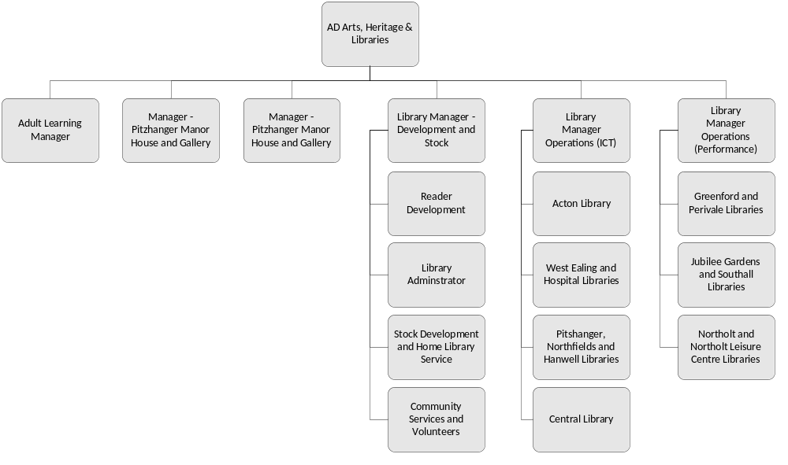
B2 Harrow Libraries Structure (Includes Accountability for Leisure)
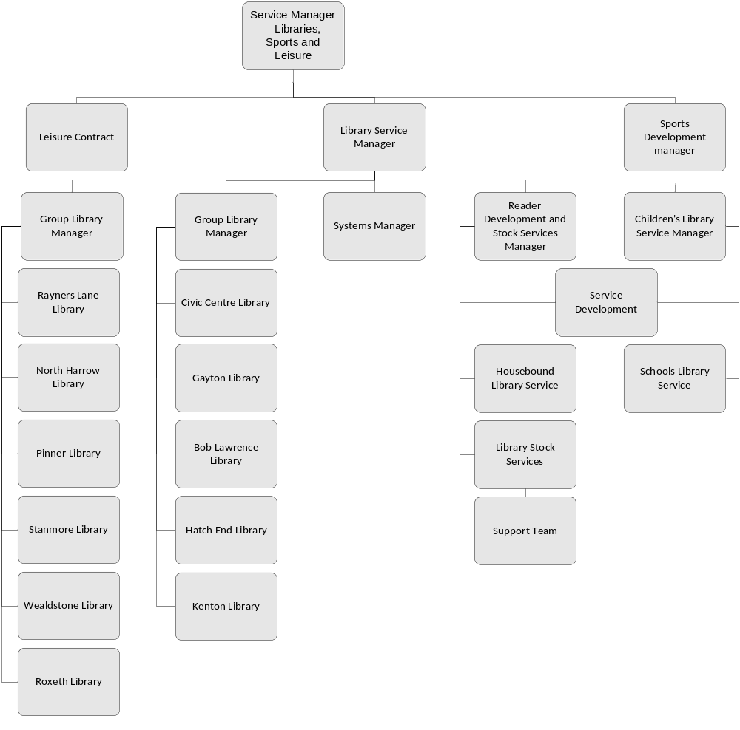

Ealing, Harrow and Brent Leisure

Shared Service
Contract Governance and SLA Agreement

Table of contents
1 Introduction 28
1.1 Introduction 28
1.2 Purpose 28
1.3 Scope 28
2 The Agreement 29
2.1 Agreement Overview 29
2.2 Periodic review of SLA 29
2.3 Individual Borough Sovereignty 29
2.4 Responsibilities of Head of Service / Assistant Director (Lead Officer) 29
3 Service AGREEMENTS 30
3.1 Service Agreement - Leisure 30
3.2 Resourcing 34
3.3 Payment Schedule 34
Appendix A – Facilities in SCope of the SLA 35
Appendix C – Structure Charts 1

Introduction

Introduction
In order to deliver the maximum cash benefit from a move to single contracts for Leisure provision across the three boroughs; and Libraries Provision across Harrow and Ealing; the options for sharing common functions have been considered throughout the development of the joint procurement.
An options paper in March 2012 recommended an approach for operational management of the Joint Contracts, with current Heads of Service remaining in place, with each borough managing a functional specialism(s) for other boroughs. Steering committee agreed that this recommended approach should be developed further to a formal proposal on the structure to support the shared model.
Following further development, the following allocation of accountabilities was developed:
- Ealing to lead on Leisure Contract Management, across three boroughs
- Each borough will retain responsibility for their own sports development teams. (Subject to on-going review)
- Harrow to lead on Libraries Contract Management for Ealing and Harrow
This proposal was presented to Steering Committee in July 2012; they agreed that this structure will be recommended to Cabinets and Executives in February and March 2013, alongside the recommended decision on successful suppliers for the Leisure and Libraries Contracts.
This paper documents the Service Level Agreement (SLA), between the boroughs that will underpin the Lead Borough management of the Contractor for the Leisure Contract

Purpose
The purpose of this document is to ensure that all required elements are in place to provide effective shared contract management of the Leisure Contractor.
The goal is that the Senior Officer in the three boroughs agree the documented SLAs as the agreed service provision between the boroughs.
The objectives of the SLA are to:
- Provide a clear and unambiguous statement of what the Customer Boroughs can expect from the Service Providing Borough
- Present measures of the Services that will be provided to ensure that performance to the SLA can be tested
- Ensure that there is a match between the expected services and the planned service delivery

Scope
The scope of the SLA includes the management of the contract to provide Leisure services. A full list of in scope facilities is listed in Appendix A.
The scope of this options review excludes the following:
- Management of retained Sport Development functions (Subject to on-going review)
- Parks Services
- Ealing Management of retained in-house leisure provision
- Brent Bridge Park Leisure Centre
- Willesden Sports Centre

The Agreement

Agreement Overview
This agreement represents a Service Level Agreement (SLA), between the following Parties:
- London Borough of Ealing (Service Provider) and London Borough of Harrow (Customer) for provision of Contract Management for Leisure Services
- London Borough of Ealing (Service Provider) and London Borough of Brent (Customer) for provision of Contract Management for Leisure Services

Periodic review of SLA
The SLA will be reviewed annually, as part of the annual contract review processes. The review will cover all aspects of the SLA e.g. Performance, Staffing, Finance etc. The service level described, anticipates a higher level of interaction with the contractor in the first year of operation of the contract.

Individual Borough Sovereignty
At Member and Senior Officer level, policy and strategic matters will remain with each borough. The level of Member engagement with the responsible officer and contractors will remain unchanged, this is captured in the Service Agreements, below.

Responsibilities of Head of Service / Assistant Director (Lead Officer)
The responsible officers in all three boroughs will retain ownership of the strategic direction of the Boroughs Leisure Services.
In all three boroughs, The Heads of Service / Assistant Directors have responsibilities that are broader than the scope of the Leisure contract. The Heads of Service / Assistant Directors will retain the responsibility as Lead Officer for Leisure for their borough; owning the subject matter strategy for their service.
The Customer Borough will ensure that all staff and facilities are handed over to the Contractor on first day of contract; and will resolve any Staff Transfer issues identified after go-live.
The SLA is owned in the Customer Borough at Head of Service Level, any additional dissemination of information to Directors, Board and Cabinet / Executive; will continue to be undertaken in a similar manner to current processes and procedures.

Development of Strategic Partnering
Ensure that any arrangements or evolving requirements with regards to Public Health Services are integrated into the Contract for each Borough

Contract Mobilisation
It is anticipated that during the first few months of the new contractual arrangements being in place, there will be additional resources needed to manage exceptions and incidents. This additional resourcing is outside of the scope of this SLA and the additional resources will be provided by the impacted borough. Arrangements for the Contract Mobilisation are covered in the implementation plan.

Service AGREEMENTS

Service Agreement - Leisure
The following Table Details the services that will be provided by London Borough of Ealing; for the Leisure Contract.

Service Area | Service Level Description | KPI
Management of Mobilisation process, staffing and facilities | Each borough will provide additional resources for mobilisation (pre and post contract start date)  Outstanding and on-going issues and actions post mobilisation; the Service Provider will manage the completion of these activities. | N/A
Meetings with Supplier  Monthly  Quarterly  Annual | Meeting to review monthly performance report and key issues with each authorities’ AO  To include progress towards the Annual Service Plan actions and forward planning to include key projects and Fees and Charges  To include overall performance review and service plan review | Minimum 10 meetings per annum with documented agendas and action plans  Minimum 3 meetings per annum with documented agendas and action plans  Meeting within 6 weeks of end of period
Review of Supplier Metrics and management information | Provision of metrics/ performance indicators and monthly report in advance of monthly operational meeting | As agreed at contract award
Site Visits and Inspections | Unannounced visit by Client Officer including walk around and inspection with Centre/Duty Officer to include performance measurement of; cleaning and housekeeping, health and safety, maintenance, staff training, customer satisfaction, facility presentation | Minimum 10 visits per annum at larger facilities and 4 per annum at smaller facilities; actions arising from inspection reports provided by Client Officer to be completed within x days; additional inspections will be undertaken to deal with specific issues.
Preparation and submission of Reports to Client  Key issues report  Monthly performance report  Quarterly progress report  Annual Report  Preparation of Reports for Members | As and when required, dependent on severity/priority of incident/issue, to include incident management and health and safety  Monthly report on performance to Senior Management in digest format with summarised headlines for individual borough service. This will need to highlight trends and see if they are localised or replicated across both areas. This will be in a standardised format with detailed and verified usage data visits, issues, IT usage, events, failure to open/provide service, IT outages, maintenance issues, PPM, customer complaints, number of member complaints dealt with  Progress towards Service Plan actions  To include significant financial milestones, review of performance against key performance indicators and targets;  Initially report bi-annually to members (moving to annually after Year 1). Actual presentation to be undertaken by Customer Head of Service | Priority 1 – within 2 hours  Priority 2 – within 24 Hours  Priority 3 – within 48 hours  Completed report submitted to Client within 2 weeks after end of calendar month  Completed report submitted to Client within 2 weeks after end of relevant quarter  Completed report submitted to Client within X weeks after the end of each Agreement year  Completed report submitted to Client by agreed due date
Preparation and submission of Plans to Client  Annual Service Plan | to include action plans for Sports Development, PPM, Marketing and Programming, Improvement and innovation, Partnerships, HR, Financial, Pricing and Memberships, ICT, Health and Safety | Completed plan created and agreed within specified timescales  Action plan arising annual service plan implemented in full  % of KPI’s achieved against target of 90%
Rectification | In the event of consistent under-performance by the contractor, to develop a performance improvement plan and manage the Contractor through to completion of the improvement plan.  Trouble shoot, co-ordinate and resolve blockages and obstacles to contract delivery on client side to ensure delivery of contract | Assurance that contract delivers to specification and tender submission.
Scrutiny reports  Area/Ward Forums | Prepare reports for Customer Head of Service and attend meetings at Customer site | Reports completed within specified timescales
Assurance  Health and Safety  Asset Management and sustainability  Maintenance  Quality | Ensure that H&S certificates are in place  Ensure that H&S certificates are in place and not expired  Fire certificates in place and not expired  Gas and Electricity safety certificates in place and not expired  ICT Security (covering firewalls and anti-virus) software maintained to most up to version  Health and Safety Plan and lead officer at each site  Formal review process  Recording and monitoring of accidents and incidents  Asbestos Management Plan  Energy Consumption  PPM  Green Travel Plan  Ensure all maintenance issues are handled in a timely manner and do not affect opening to the public. In particular, if either borough retains any maintenance functions, to ensure smooth relationships between maintenance provider and service provider. Agree process with Customer for funding of projects over £5K  Integrated Management System developed | 100% of required certificates in place  EMAS standards achieved and maintained  % reduction in utilities use against agreed targets  Client Officer inspections and external audit of PPM works and plans  Achievement of Quest Entry or Plus and ratings as per spec  IFI  IIP  National Benchmarking Service  Service Improvement Plans
Member Enquiries | Research the enquiry and provide a draft response to the Senior Officer of the relevant borough. | With XX Days – in line with Borough procedure
Customer Complaints | Investigate the complaint and provide a draft response to the Senior Officer of the relevant borough. | With XX Days -in line with Borough procedure
Dispute Resolution | Supplier/Customer | TBC

Resourcing

Specialism | Current Resources | Planned Resourcing
Leisure Contract Management | - Harrow – 1 x Client Manager  - Ealing – 1 x Contract Manager; 1 x Contract Officer  - Brent – 0.5 x Contract Officer (vacant) | - 1 x Client Manager  - 2 x Client Officers

Payment Schedule
The following table outlines the payments between Boroughs

Service Provided | Description | Payment
Contract Management of Leisure Services Contract to Harrow | 3 x Leisure Centres | TBC
Contract Management of Leisure Services Contract to Brent | 1 x Leisure Centres | TBC

Other

Appendix A – Facilities in SCope of the SLA
The Leisure SLA scope includes ten Leisure Centres and associated community sports and leisure services:

On commencement of the Agreement in June 2013:
- Northolt Leisure Centre (Ealing Council)
- Perivale Park Track (Ealing Council)

On commencement of the Agreement (following expiry of the current leases and management agreement), in June 2013:
- Harrow Leisure Centre (Harrow Council)
- Hatch End Swimming Pool (Harrow Council)
- Bannister Outdoor Sports Centre (Harrow Council)

From 1st November 2013, following expiry of the current lease and management agreement:
- Vale Farm Sports Centre (Brent Council)

From 1st May 2014 on opening of new Acton Town Hall building:
- Acton Town Hall Leisure Centre (Ealing Council)

From 1st October 2018, following expiry of the current lease and leisure management agreement:
- Gurnell Leisure Centre (Ealing Council)

From 1st November 2018, following expiry of current dual use management agreements at:
- Dormers Wells Leisure Centre (Ealing Council)
- Swift Road Outdoor Sport Centre (Ealing Council)

TBC - LBE Provisional Sites
- Southall Sports Centre
- Twyford Sports Centre
- Elthorne Sports Centre
- Northolt High School Sports Centre

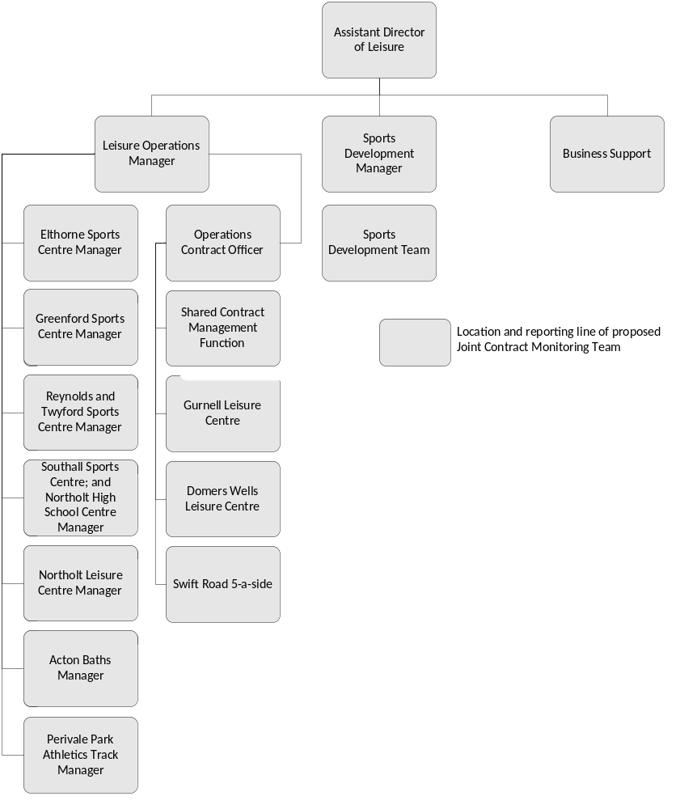
Appendix C – Structure Charts
C1 Active Ealing Structure (Part of Leisure Services)
C2 Brent Leisure Structure

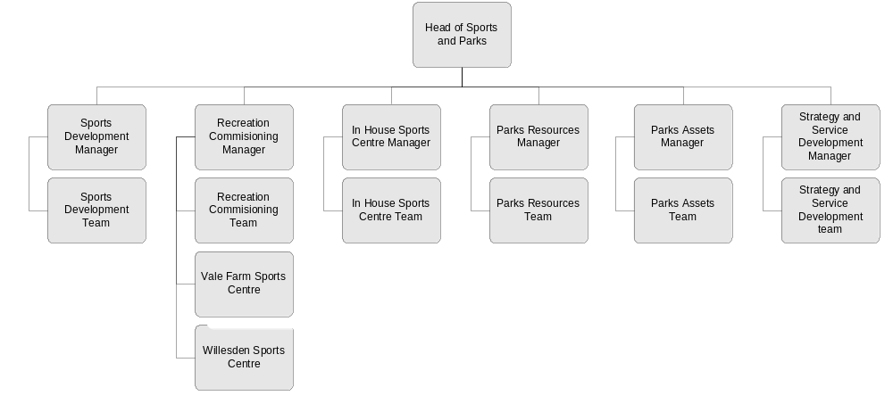
C3 Harrow Libraries Structure (Includes Accountability for Leisure Contract)


